LAPORAN PRAKTIKUM

PEMROGRAMAN 1

Nama : Mochammad Fahrudin

Npm : 4513210024

1. Nilai ascending

//Program 01A

public class nilaiascen{

public static void main (String[] args){

for(int line =1; line <= 9; line++){

for(int j=1; j <= line; j++){

System.out.print(line);

}

System.out.println("");

}

}

}

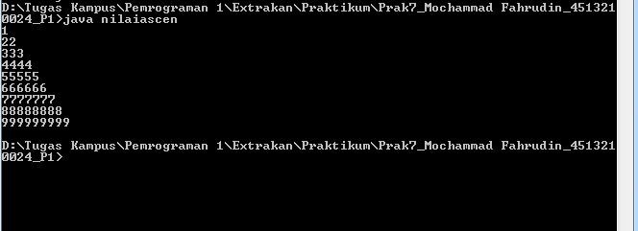

1. Nilai descending

//Program 01B

public class nilaidescen{

public static void main (String[] args){

for(int line =9 ; line >= 1; line--){

for(int j=1; j <= line; j++){

System.out.print(line);

}

System.out.println("");

}

}

}

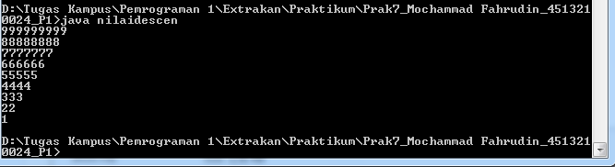

1. Ascengajil.java

//Program 01C

import java.util.Scanner;

public class ascenganjil {

public static void main(String[] args) {

int i;

int j;

Scanner masukan = new Scanner(System.in);

System.out.print("Masukkan batas bilangannya : ");

int batas = masukan.nextInt();

for(i=1;i<=batas;i++)

{

for(j=1;j<=i;j++)

{

if(i%2==1){

System.out.print(i+" ");

}

}

System.out.println();

}

}

}

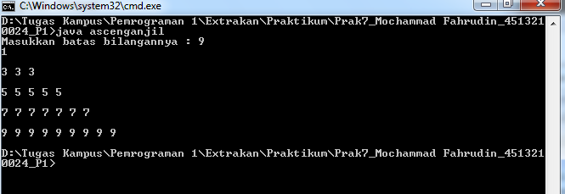

1. Kalkulator.java

//program 04

import java.util.Scanner;

public class kalkulator

{

public static void main(String[] args)

{

int Jumlah;

int Nilai1;

int Nilai2;

Scanner scan = new Scanner(System.in);

//menampilkan menu PILIHAN

System.out.println("MENU PILIHAN : ");

System.out.println("___________________________________");

System.out.println("1. Penjumlahan");

System.out.println("2. Pengurangan");

System.out.println("3. Perkalian");

System.out.println("4. Pembagian");

System.out.println("5. MOD");

System.out.println("");

//pengguna memasukkan nomor pesanan

System.out.print("Masukkan Nomor PILIHAN : ");

int Menu = scan.nextInt();

System.out.println("___________________________________");

switch(Menu){

case 1 :

System.out.println("Menu yang Anda Pilih Penjumlahan ");

System.out.print("Nilai 1 : ");

Nilai1 = scan.nextInt();

System.out.print("Nilai 2 : ");

Nilai2 = scan.nextInt();

Jumlah = Nilai1 + Nilai2;

System.out.print("Hasil nya : ");

System.out.print(Jumlah);

break;

case 2:

System.out.println("Menu yang Anda Pilih Pengurangan ");

System.out.print("Nilai 1 : ");

Nilai1 = scan.nextInt();

System.out.print("Nilai 2 : ");

Nilai2 = scan.nextInt();

Jumlah = Nilai1 - Nilai2;

System.out.print("Hasil nya : ");

System.out.print(Jumlah);

break;

case 3:

System.out.println("Menu yang Anda Pilih Perkalian ");

System.out.print("Nilai 1 : ");

Nilai1 = scan.nextInt();

System.out.print("Nilai 2 : ");

Nilai2 = scan.nextInt();

Jumlah = Nilai1 * Nilai2;

System.out.print("Hasil nya : ");

System.out.print(Jumlah);

break;

case 4:

System.out.println("Menu yang Anda Pilih Pembagian ");

System.out.print("Nilai 1 : ");

Nilai1 = scan.nextInt();

System.out.print("Nilai 2 : ");

Nilai2 = scan.nextInt();

Jumlah = Nilai1/Nilai2;

System.out.print("Hasil nya : ");

System.out.print(Jumlah);

break;

case 5:

System.out.println("Menu yang Anda Pilih MOD");

System.out.print("Nilai 1 : ");

Nilai1 = scan.nextInt();

System.out.print("Nilai 2 : ");

Nilai2 = scan.nextInt();

Jumlah = Nilai1%Nilai2;

System.out.print("Hasil nya : ");

System.out.print(Jumlah);

break;

default:

System.out.print("Menu yang anda pilih tidak tersedia !!");

break;

}

}

}

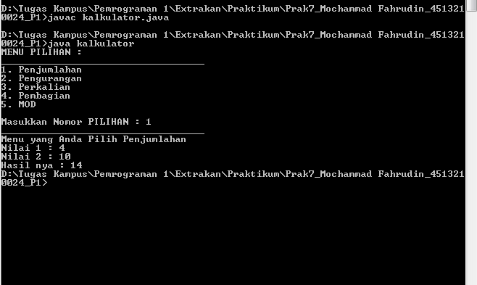

1. Segitigaganjil.java

//Program 01D

import java.util.Scanner;

public class segitigaganjil1 {

public static void main(String[] args) {

int i;

int j;

Scanner masukan = new Scanner(System.in);

System.out.print("Masukkan batas bilangannya : ");

int batas = masukan.nextInt();

int z=1;

for(i=batas;i>0;i--)

{

for(j=1;j<=i;j++)

{

if(i%2==1){

System.out.print(" ");

}

}

for(j=1;j<=z;j++)

{

if(i%2==1){

System.out.print(z+"");

}

}

System.out.println(" ");

z++;

}

}

}

